**Full Stack Development with MERN**

**Project Documentation format**

**1. Introduction**

**Project Title:** Book Nest

**Team Members:**

Shreya Agarwal 22BCE2179 (TEAM LEADER) Monesha Ra 22BPS1190  
Venu Gopal 22BCE2829  
Anisha Plawat 22BCE0275

**2. Project Overview**

**Purpose:** The purpose of this bookstore application is to provide users with a convenient platform to browse, purchase, and manage books. The application aims to offer a seamless user experience by allowing users to view detailed information about books, add them to their cart or wishlist, and complete purchases.

**Features:**

• **Browse Books**: View a list of books with details such as title, author, category, and price.

• **Detailed Book Page**: Access detailed information about each book, including an image, description, and a link to the book's PDF.

• **Add to Cart**: Add books to the shopping cart and manage quantities.

• **Add to Wishlist**: Save favorite books to a wishlist for future reference.

• **Purchase Books**: Complete purchases and manage items in the cart.

• **Best Sellers and Other Books**: View sections for best-selling books and other recommended titles.

• **Wishlist Management**: View, add, and remove books from the wishlist.

**3. Architecture**

**Frontend**

The frontend is developed using React, a popular JavaScript library for building user interfaces. Key components include:

* **Home**: Displays the main page with banners, best sellers, featured books, promotions, and reviews.
* **BestSellerBooks**: Fetches and displays the top-selling books.
* **FavBook**: Showcases featured books and statistics.
* **OtherBooks**: Lists additional recommended books.
* **Shop**: Allows users to browse all books, add them to the cart or wishlist.
* **SingleBook**: Shows detailed information about a selected book.
* **Wishlist**: Manages the user's wishlist and allows for adding or removing books.

**Backend**

The backend is built with Node.js and Express.js. It handles API requests, interacts with the MongoDB database, and performs CRUD operations. Key routes include:

* **Books**: Retrieve, add, update, and delete books.
* **Cart**: Manage items in the shopping cart, including adding, removing, and updating quantities.
* **Wishlist**: Manage wishlist items, including adding and removing books.

**Database**

The database uses MongoDB and consists of the following collections:

* **bookCollection**: Stores information about books.
* **cartCollection**: Manages items in the user's cart.
* **wishlistCollection**: Keeps track of books added to the user's wishlist.

**Schemas**

* **BookCollection Schema**:
  + _id: ObjectId
  + authorName: String
  + bookTitle: String
  + category: String
  + bookDescription: String
  + imageURL: String
  + bookPDFLink: String
  + price: Number
* **CartCollection Schema**:
  + _id: ObjectId
  + bookId: ObjectId
  + authorName: String
  + bookTitle: String
  + category: String
  + bookDescription: String
  + imageURL: String
  + bookPDFLink: String
  + price: Number
  + quantity: Number
* **WishlistCollection Schema**:
  + _id: ObjectId
  + bookId: ObjectId
  + authorName: String
  + bookTitle: String
  + category: String
  + bookDescription: String
  + imageURL: String
  + bookPDFLink: String
  + price: Number

**4. Setup Instructions**

**Prerequisites**

* **Node.js**: Ensure Node.js is installed on your system.
* **MongoDB**: Ensure MongoDB is running and accessible.

**Installation:** Step-by-step guide to clone, install dependencies, and set up the environment variables.

**To check if node.**js is installed – node -v

**To check if npm is installed –** npm -v

**To install project dependencies –** npm install

**To install other dependencied –** npm install nodemon mongoose express

**To run the server(backend) –** npm start

**To run the frontend –** npm run dev

**5. Folder Structure**

* **Frontend:** Describe the structure of the React frontend.

**/src/home :** The landing page and it’s components are present in this folder

**/src/shop:** Contains the collection of Books to be purchased

**/src/wishlist:** Users can add their favorite books here

**/src/cart:** Usrs can proceed to buy the books from this page

**/src/assets:** Images used in the home page stored here

**/src/components:** Components such as navbar, footer and bookCard are present

**/src/dashboard:** The seller dashboard

* **Backend:** Explain the organization of the Node.js backend.

**index.**js : This is a JavaScript file that likely serves as the entry point for the server application.

**package-**lock.json: This file contains metadata about the project's dependencies, including version numbers and installation instructions.

**package.**json: This file contains metadata about the project, including its name, version, dependencies, and scripts.

**6. Running the Application**

* Provide commands to start the frontend and backend servers locally.
  + **Frontend:** npm run dev in the client directory.
  + **Backend:** npm start in the server directory.

**7. API Documentation**

### Endpoints

#### Books

* **GET /all-books**
  + Retrieves all books.
  + **Response**: Array of books.
* **GET /book/**
  + Retrieves a book by ID.
  + **Response**: Book object.
* **POST /upload-book**
  + Adds a new book.
  + **Request Body**: Book object.
  + **Response**: Confirmation of addition.
* **PATCH /books/**
  + Updates a book by ID.
  + **Request Body**: Updated book data.
  + **Response**: Confirmation of update.
* **DELETE /books/**
  + Deletes a book by ID.
  + **Response**: Confirmation of deletion.

#### Cart

* **POST /add-to-cart/**
  + Adds a book to the cart.
  + **Response**: Added cart item.
* **DELETE /cart/**
  + Removes an item from the cart.
  + **Response**: Confirmation of removal.
* **PUT /cart/increment/**
  + Increments the quantity of an item in the cart.
  + **Response**: Updated cart item.
* **PUT /cart/decrement/**
  + Decrements the quantity of an item in the cart.
  + **Response**: Updated cart item.
* **GET /cart**
  + Retrieves all cart items.
  + **Response**: Array of cart items.

#### Wishlist

* **POST /add-to-wishlist/**
  + Adds a book to the wishlist.
  + **Response**: Added wishlist item.
* **DELETE /wishlist/**
  + Removes an item from the wishlist.
  + **Response**: Confirmation of removal.
* **GET /wishlist**
  + Retrieves all wishlist items.
  + **Response**: Array of wishlist items.

**8. Authentication**

* Explain how authentication and authorization are handled in the project.

**Authentication:** Managed by Firebase Authentication using email/password and Google sign-in methods. The AuthProvider component handles authentication state and provides authentication operations.

**Authorization:** User authentication status is checked before granting access to specific routes or functionalities.

* Include details about tokens, sessions, or any other methods used.

**Token Management**

* **Generation**: Firebase generates an ID token (JWT) upon user sign-in or registration.
* **Storage**: Tokens are stored in local or session storage automatically.
* **Refresh**: Firebase automatically refreshes tokens to maintain the session seamlessly.

**9. User Interface**

**Home Page**



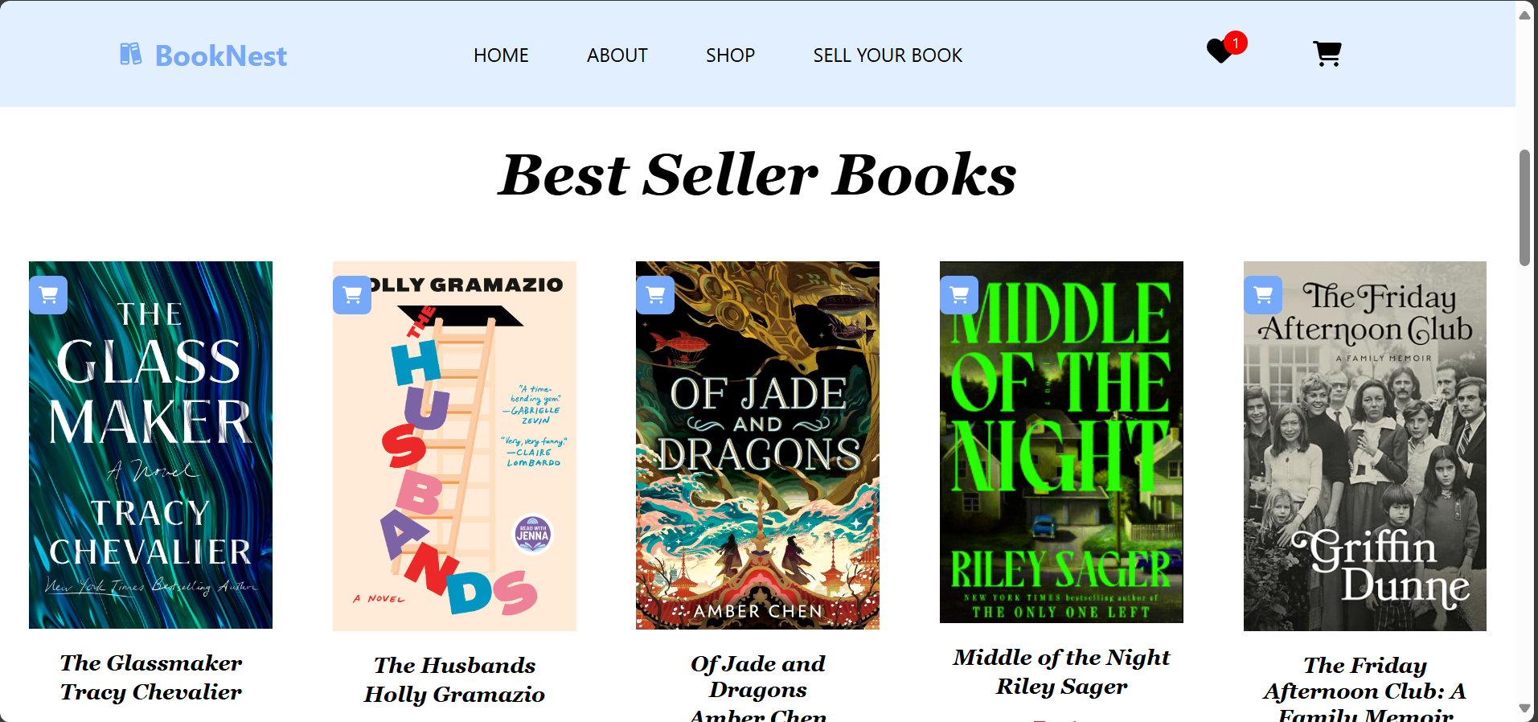

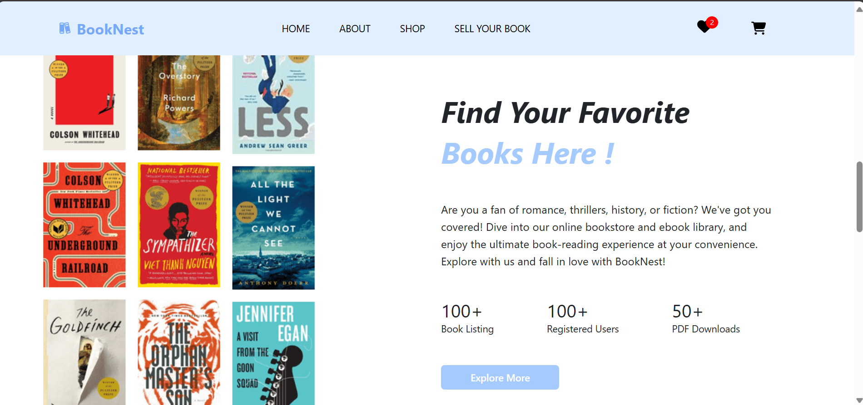

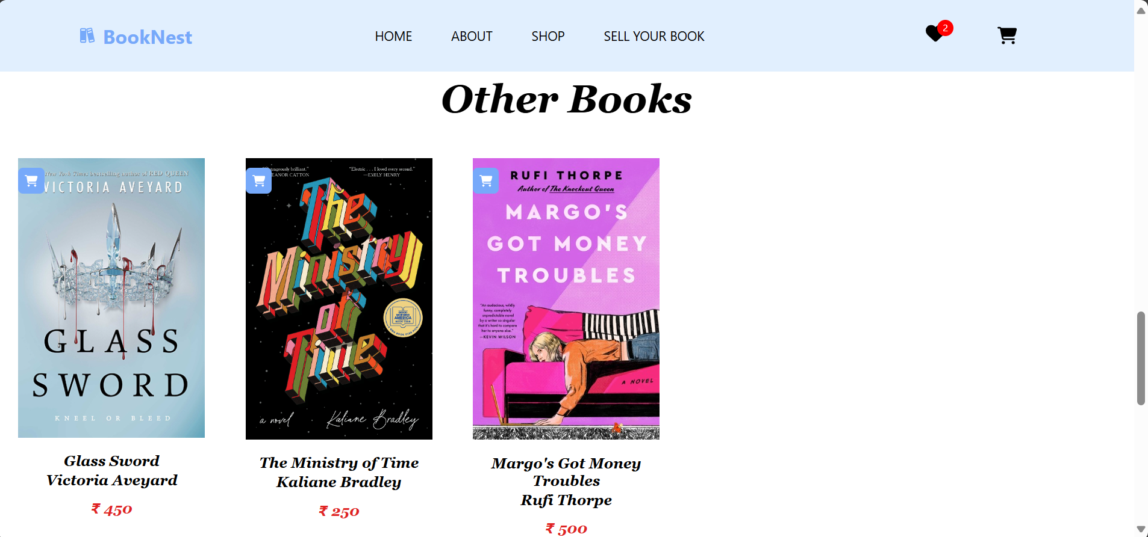

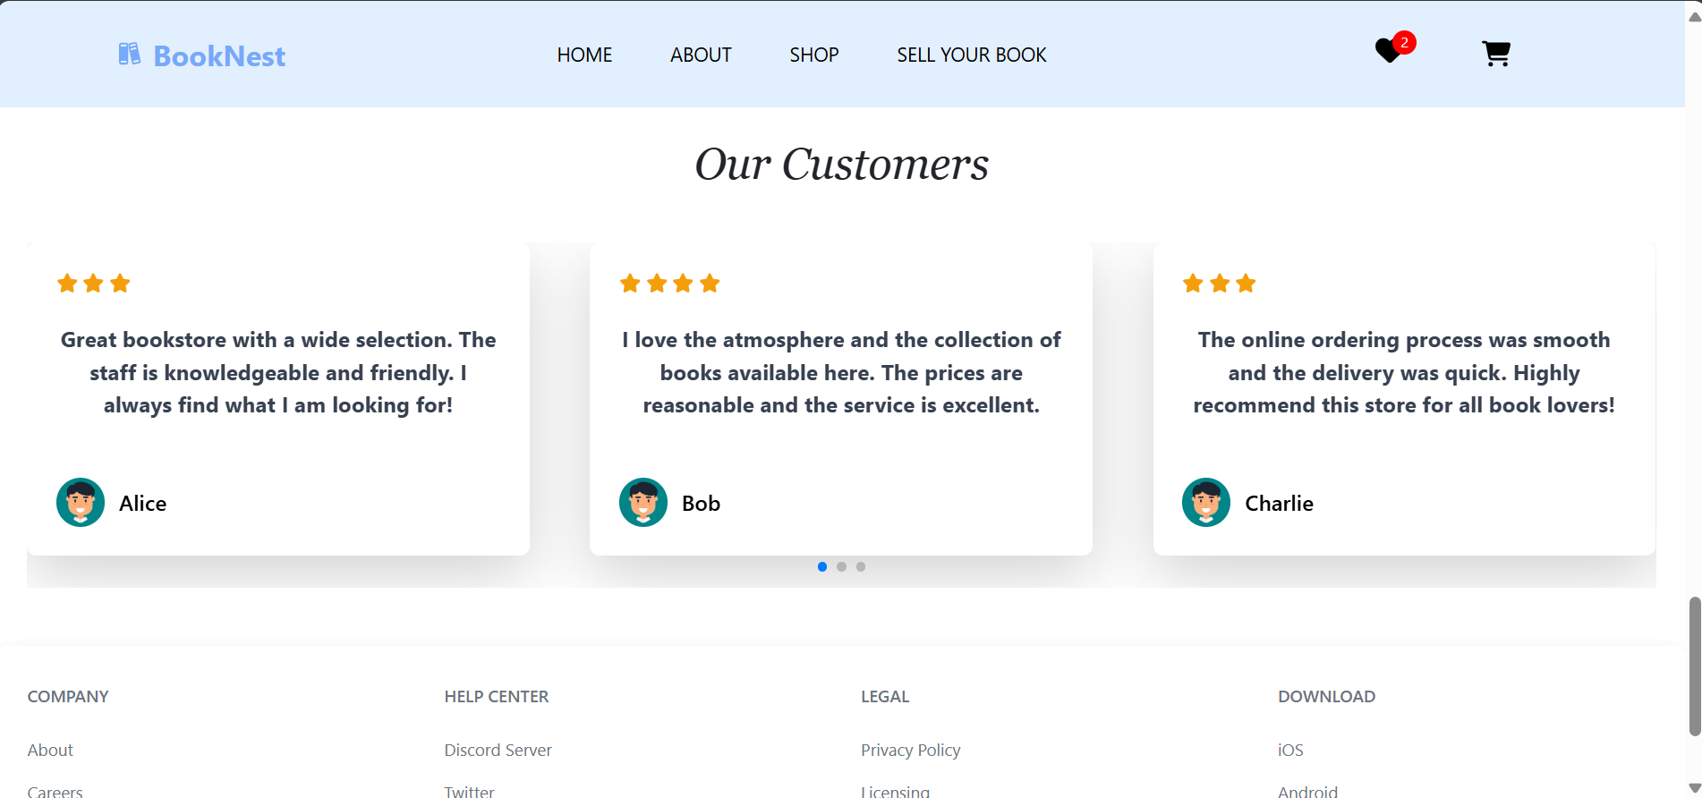

**About Page**

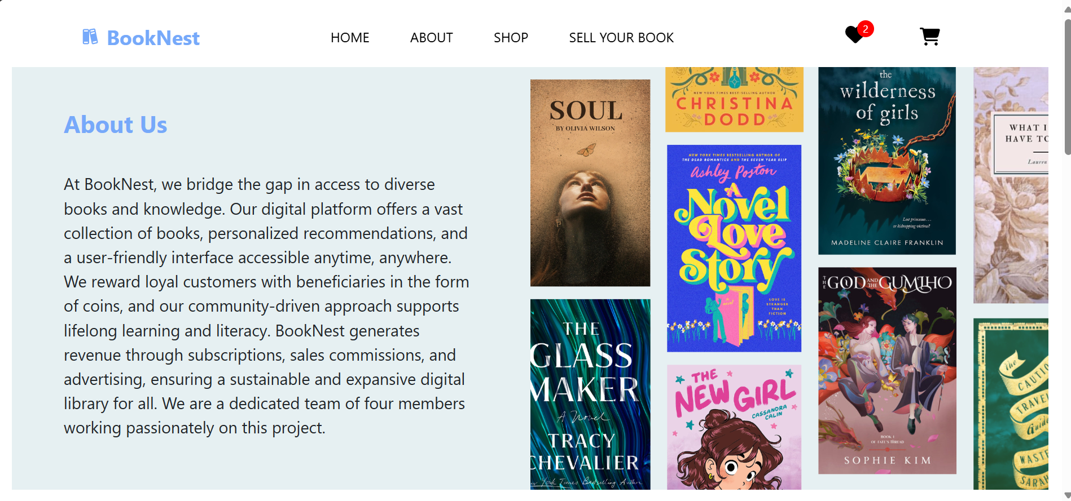

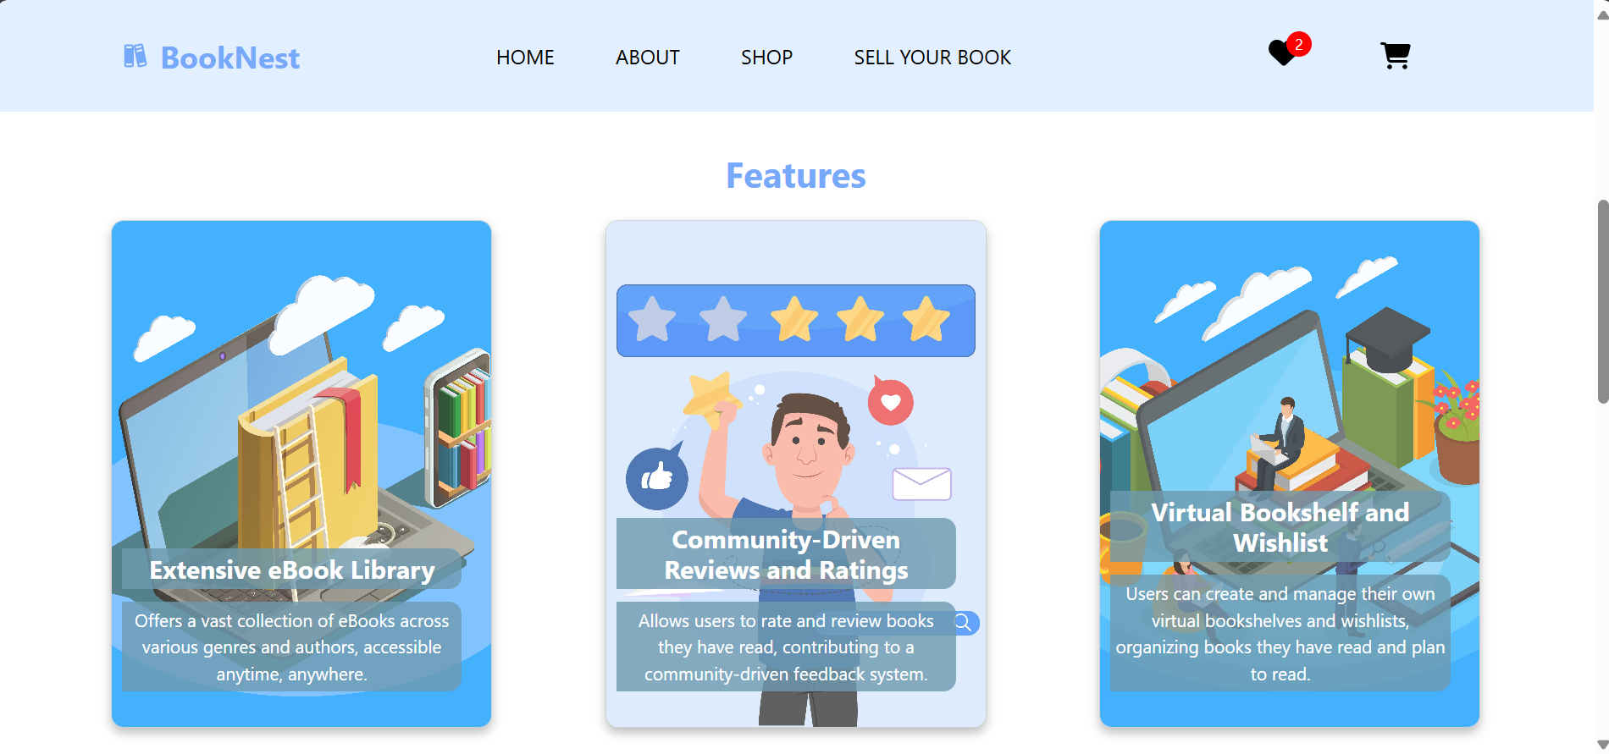



**Shop Page**



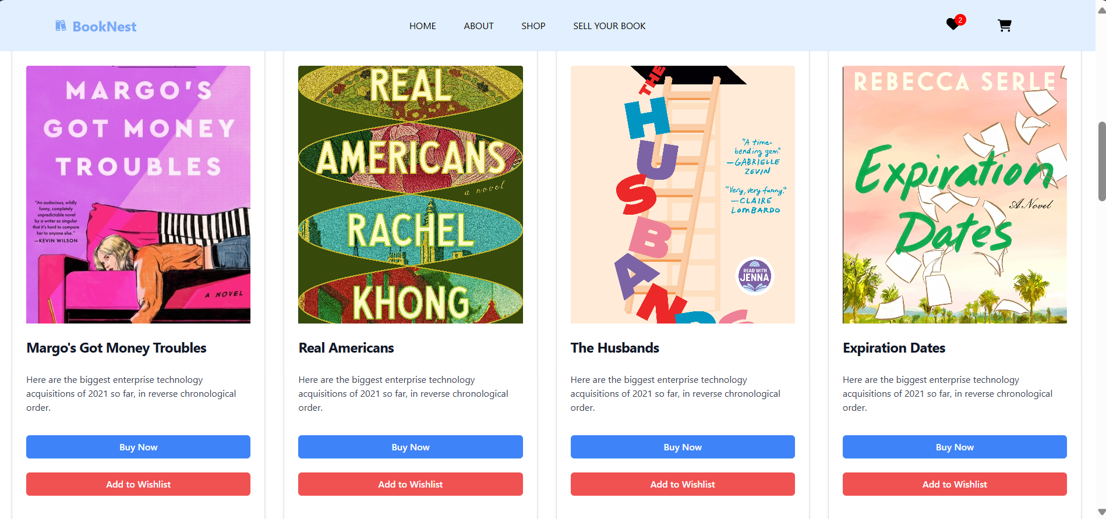

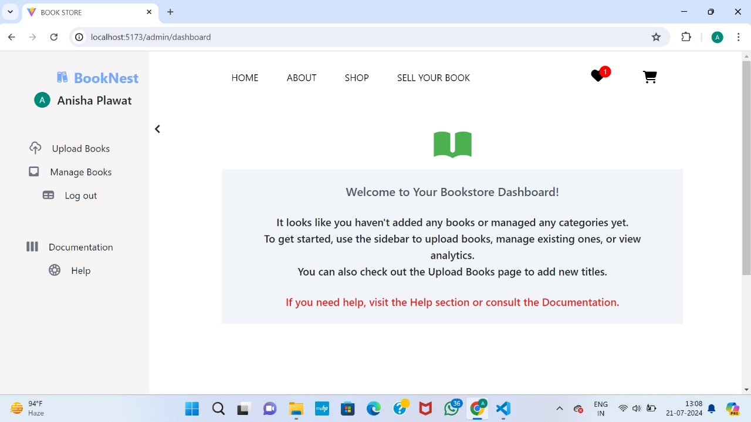**Sell Your Book Page**

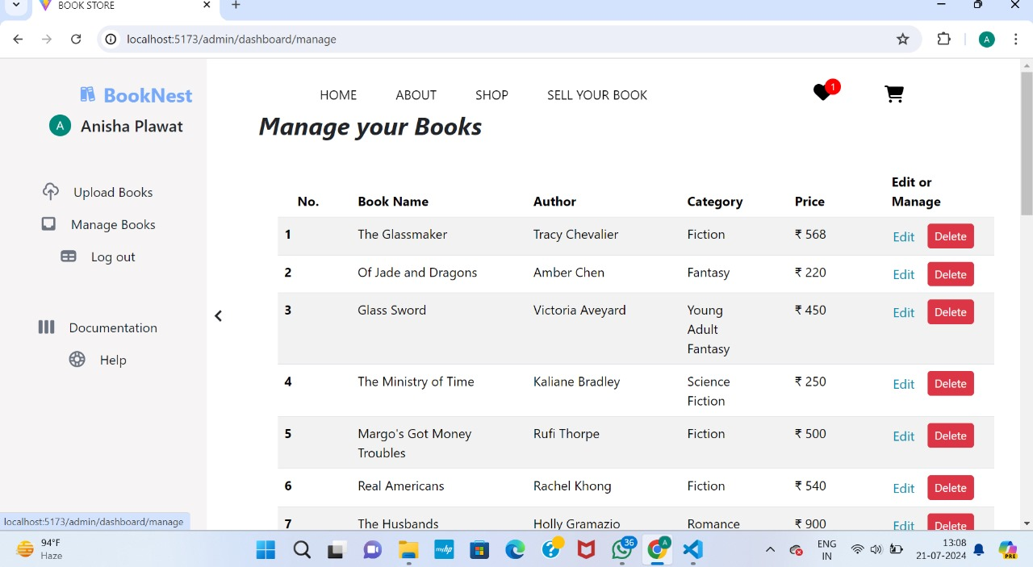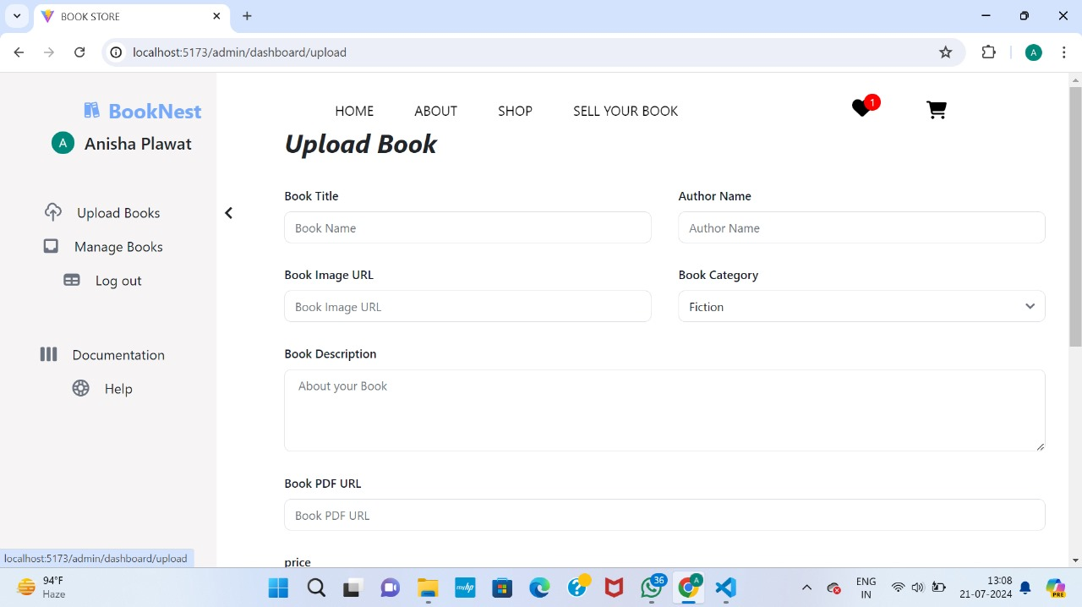

**Wish List Page**

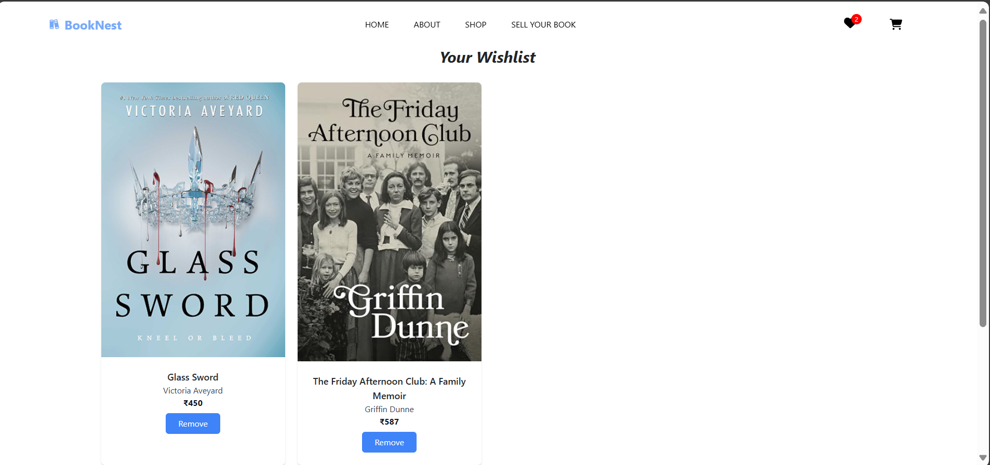

**Cart Page**

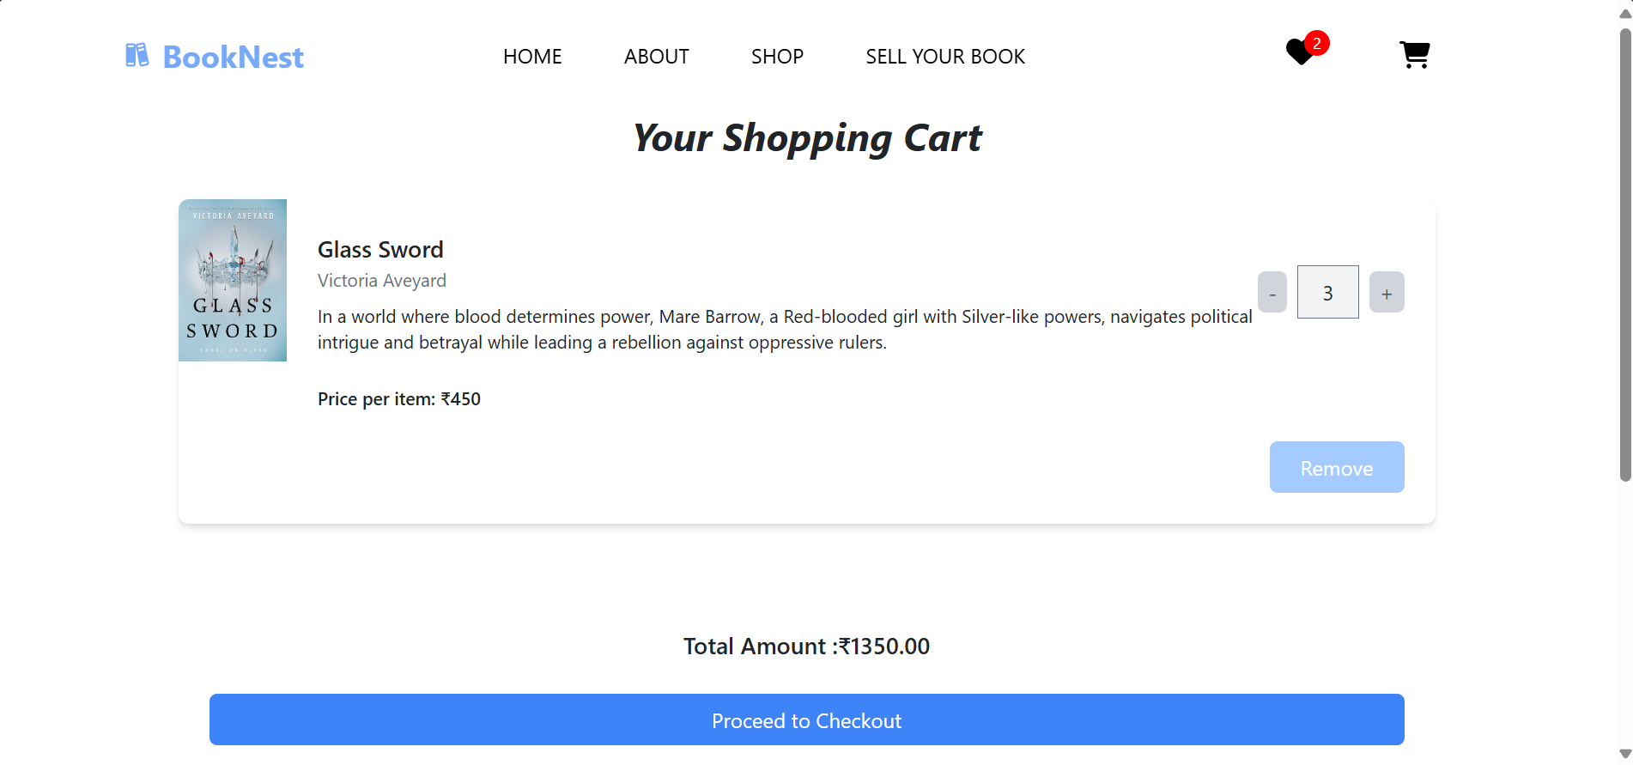

**10. Testing**

Testing was done by hosting localhost:5173 for frontend and localhost:5000 for backend on the system using appropriate commands( npm run dev for home and npm start for server).  
Than each and every user stories and functionalities were checked by running them various times.  
Whole website was explored thoroughly , and each functionality was verified.

**11. Screenshots or Demo**

* Provide screenshots or a link to a demo (if available) to showcase the application.

Link -https://drive.google.com/file/d/18Kqe95Ma4es8OxMkrsSy2ZBkDHan4N4q/view?usp=sharing

**12. Known Issues**

* Document any known bugs or issues that users or developers should be aware of.

1. User Logout Redirection Issue

Description:

- After logging out of the page, the user is not redirected to another page. Despite being logged out, the content remains visible.

Steps to Reproduce:

1. Log in to the application.

2. Navigate to any page with content visible to logged-in users.

3. Click the logout button.

4. Observe that the content is still visible even though the user has been logged out.

Impact:

- Users may be confused as to whether they have successfully logged out.

- Sensitive content remains visible, which could pose a security risk.

Workaround:

- Refreshing the page manually after logging out hides the content and shows the login page.

2. Payment Portal Not Opening on Checkout

Description:

* The payment portal does not open when the checkout button is clicked due to security reasons.

Steps to Reproduce:

1. Add items to the cart.
2. Proceed to the checkout page.
3. Click the checkout button.
4. Observe that the payment portal does not open.

Impact:

* Users are unable to complete the purchase process.
* Demonstrates the current limitation of the project as a non-production implementation.

Workaround:

* Currently, there is no workaround since the payment portal has not been implemented for security reasons.

**13. Future Enhancements**

* Outline potential future features or improvements that could be made to the project.

**1. Implement Secure Payment Gateway**

* **Description**: Integrate a secure and reliable payment gateway to allow users to complete purchases directly on the website.
* **Benefits**: Enhances user trust and convenience, enabling real transactions.
* **Considerations**: Ensure compliance with PCI-DSS standards for secure transactions.

**2. Improve User Authentication and Authorization**

* **Description**: Enhance security by implementing features like multi-factor authentication (MFA) and role-based access control (RBAC).
* **Benefits**: Provides better security for user accounts and ensures appropriate access levels for different users.
* **Considerations**: Balance between security and user convenience.

**3. Advanced Search and Filtering Options**

* **Description**: Implement advanced search functionality with filters for book categories, authors, ratings, and price ranges.
* **Benefits**: Improves user experience by making it easier to find specific books.
* **Considerations**: Optimize search performance to handle large datasets efficiently.

**4. Recommendation System**

* **Description**: Develop a recommendation system that suggests books to users based on their browsing history, purchases, and ratings.
* **Benefits**: Increases user engagement and sales by providing personalized recommendations.
* **Considerations**: Use machine learning algorithms to enhance recommendation accuracy.

**5. User Reviews and Ratings**

* **Description**: Allow users to leave reviews and ratings for books they have read.
* **Benefits**: Provides valuable feedback for other users and helps in decision-making.
* **Considerations**: Implement moderation to handle inappropriate content.